Visvesvaraya Technological University

jnana sangama, Belagavi-590018


A Seminar Report
on

“RFID Based Student Attendance Management System”

Submitted in partial fulfillment of the requirements for the VIII Semester, Bachelor of Engineering in Computer Science and Engineering
of Visvesvaraya Technological University, Belagavi

Submitted by:

R SAIPRASANTH
(1RN14CS075)

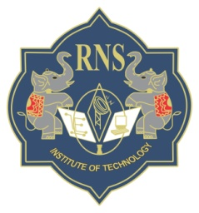

Department of Computer Science and Engineering
RNS Institute of Technology
Channasandra, Dr. Vishnuvaradana Road, Bengaluru-560 098

2017-2018

RNS Institute of Technology
Channasandra, Dr. Vishnuvaradana Road,
Bengaluru-560 098

Department of Computer Science & Engineering

CERTIFICATE

Certified that the Seminar on topic “RFID Based Student Attendance Management System” has been successfully presented at RNS Institute of Technology by R SAIPRASANTH, bearing USN 1RN14CS075, in partial fulfillment of the requirements for the VIII Semester, Bachelor of Engineering in Computer Science and Engineering of Visvesvaraya Technological University, Belagavi during academic year 2017-2018. It is certified that all corrections/suggestions indicated for Internal Assessment have been incorporated in the report deposited in the departmental library. The Seminar report has been approved as it satisfies the academic requirements in respect of Seminar work for the said degree.

Mr. Devaraju B M Mr. Devaraju B M
Asst. Prof, Guide Asst. Prof., Seminar Coordinator

Dr. G T Raju Dr. M K Venkatesha
Dean of Engg., Prof. and Head Principal

